**GHULAM ISHAQ KHAN INSTITUTE OF ENGINEERING SCIENCES AND TECHNOLOGY**

**CS331-L : OPERATING SYSTEMS LAB**

**Lab 11**

**Name:** Muhammad Bilal

**Reg no:** 2022360

**CODE:**

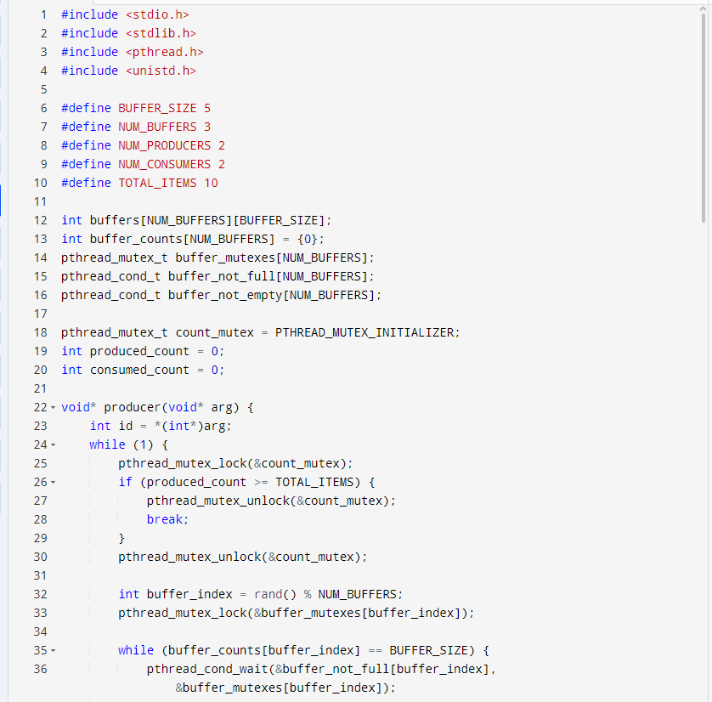

**Output:**

**TASK2**

**CODE:**

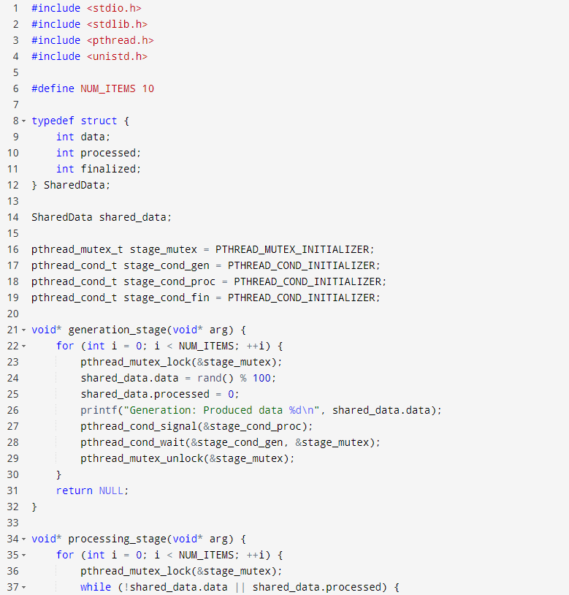

**Output:**

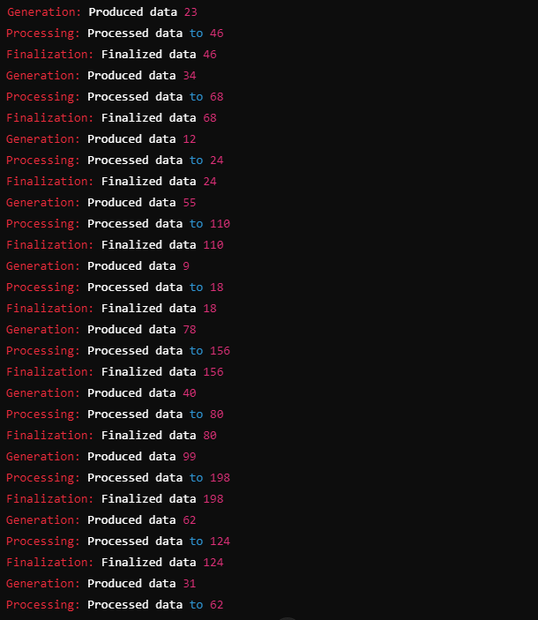

**TASK3**

**CODE:**

